HTTP 1.1 vs HTTP 2.0

Ref copy URL :

[ <https://i0.wp.com/css-tricks.com/wp-content/uploads/2017/02/image02.gif?ssl=1> ]

[ <https://lnxpgn.github.io/images/http.png> ]

# Performance difference between HTTP2 and HTTP1.1

**HTTP2 is much faster and more reliable than HTTP1**. HTTP1 loads a single request for every TCP connection, while HTTP2 avoids network delay by using multiplexing. HTTP is a network delay sensitive protocol in the sense that if there is less network delay, then the page loads faster.

### ***Introduction***

The Hypertext Transfer Protocol, or HTTP, is an application protocol that has been the de facto standard for communication on the World Wide Web since its invention in 1989. From the release of HTTP/1.1 in 1997 until recently, there have been few revisions to the protocol. But in 2015, a reimagined version called HTTP/2 came into use, which offered several methods to decrease latency, especially when dealing with mobile platforms and server-intensive graphics and videos. HTTP/2 has since become increasingly popular, with some estimates suggesting that around a third of all websites in the world support it. In this changing landscape, web developers can benefit from understanding the technical differences between HTTP/1.1 and HTTP/2, allowing them to make informed and efficient decisions about evolving best practices.

After reading this article, you will understand the main differences between HTTP/1.1 and HTTP/2, concentrating on the technical changes HTTP/2 has adopted to achieve a more efficient Web protocol.

## ***Background***

To contextualize the specific changes that HTTP/2 made to HTTP/1.1, let’s first take a high-level look at the historical development and basic workings of each.

### **HTTP/1.1**

Developed by Timothy Berners-Lee in 1989 as a communication standard for the World Wide Web, HTTP is a top-level application protocol that exchanges information between a client computer and a local or remote web server. In this process, a client sends a text-based request to a server by calling a method like GET or POST. In response, the server sends a resource like an HTML page back to the clien

This request uses the GET method, which asks for data from the host server listed after Host:. In response to this request, the example.com web server returns an HTML page to the requesting client, in addition to any images, stylesheets, or other resources called for in the HTML. Note that not all of the resources are returned to the client in the first call for data. The requests and responses will go back and forth between the server and client until the web browser has received all the resources necessary to render the contents of the HTML page on your screen.

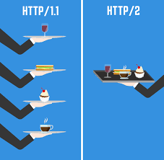

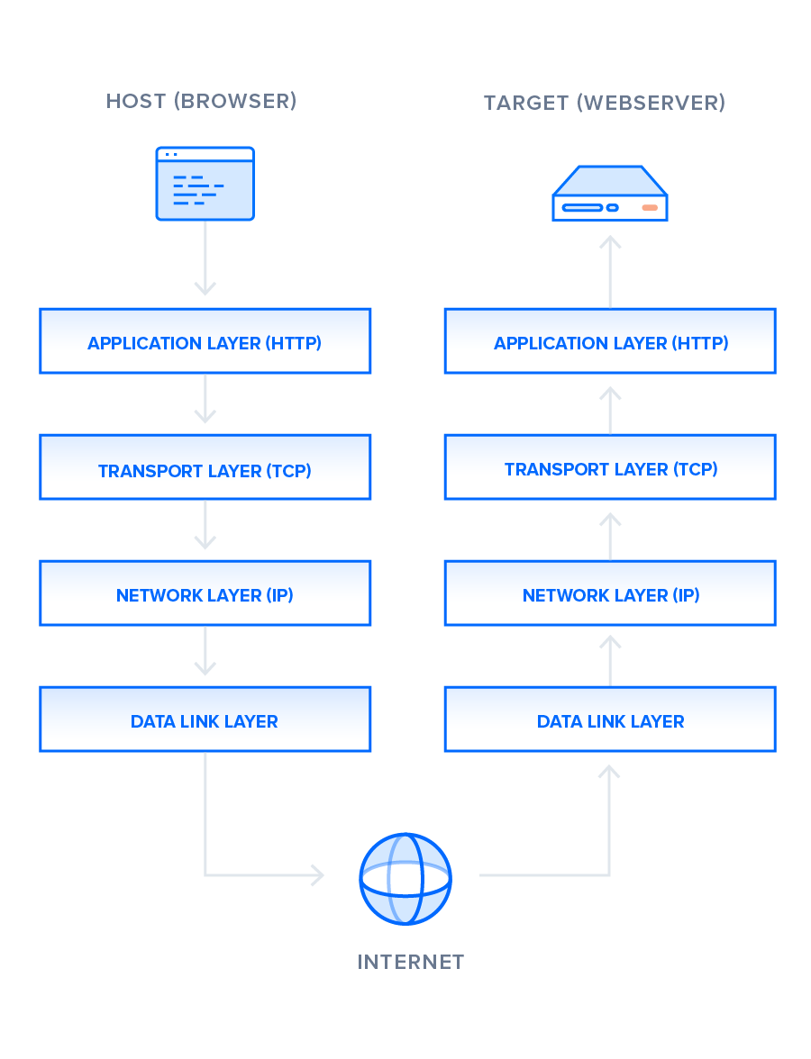

There is much to discuss about the lower levels of this stack, but in order to gain a high-level understanding of HTTP/2, you only need to know this abstracted layer model and where HTTP figures into it.

With this basic overview of HTTP/1.1 out of the way, we can now move on to recounting the early development of HTTP/2.

### **HTTP/2**

HTTP/2 began as the SPDY protocol, developed primarily at Google with the intention of reducing web page load latency by using techniques such as compression, multiplexing, and prioritization. This protocol served as a template for HTTP/2 when the Hypertext Transfer Protocol working group httpbis of the [IETF (Internet Engineering Task Force)](https://www.ietf.org/) put the standard together, culminating in the publication of HTTP/2 in May 2015. From the beginning, many browsers supported this standardization effort, including Chrome, Opera, Internet Explorer, and Safari. Due in part to this browser support, there has been a significant adoption rate of the protocol since 2015, with especially high rates among new sites.

From a technical point of view, one of the most significant features that distinguishes HTTP/1.1 and HTTP/2 is the binary framing layer, which can be thought of as a part of the application layer in the internet protocol stack. As opposed to HTTP/1.1, which keeps all requests and responses in plain text format, HTTP/2 uses the binary framing layer to encapsulate all messages in binary format, while still maintaining HTTP semantics, such as verbs, methods, and headers. An application level API would still create messages in the conventional HTTP formats, but the underlying layer would then convert these messages into binary. This ensures that web applications created before HTTP/2 can continue functioning as normal when interacting with the new protocol.

The conversion of messages into binary allows HTTP/2 to try new approaches to data delivery not available in HTTP/1.1, a contrast that is at the root of the practical differences between the two protocols. The next section will take a look at the delivery model of HTTP/1.1, followed by what new models are made possible by HTTP/2.

## **Delivery Models**

As mentioned in the previous section, HTTP/1.1 and HTTP/2 share semantics, ensuring that the requests and responses traveling between the server and client in both protocols reach their destinations as traditionally formatted messages with headers and bodies, using familiar methods like GET and POST. But while HTTP/1.1 transfers these in plain-text messages, HTTP/2 encodes these into binary, allowing for significantly different delivery model possibilities. In this section, we will first briefly examine how HTTP/1.1 tries to optimize efficiency with its delivery model and the problems that come up from this, followed by the advantages of the binary framing layer of HTTP/2 and a description of how it prioritizes requests.

### **HTTP/1.1 — Pipelining and Head-of-Line Blocking**

The first response that a client receives on an HTTP GET request is often not the fully rendered page. Instead, it contains links to additional resources needed by the requested page. The client discovers that the full rendering of the page requires these additional resources from the server only after it downloads the page. Because of this, the client will have to make additional requests to retrieve these resources. In HTTP/1.0, the client had to break and remake the TCP connection with every new request, a costly affair in terms of both time and resources.

HTTP/1.1 takes care of this problem by introducing persistent connections and pipelining. With persistent connections, HTTP/1.1 assumes that a TCP connection should be kept open unless directly told to close. This allows the client to send multiple requests along the same connection without waiting for a response to each, greatly improving the performance of HTTP/1.1 over HTTP/1.0.

Unfortunately, there is a natural bottleneck to this optimization strategy. Since multiple data packets cannot pass each other when traveling to the same destination, there are situations in which a request at the head of the queue that cannot retrieve its required resource will block all the requests behind it. This is known as head-of-line (HOL) blocking, and is a significant problem with optimizing connection efficiency in HTTP/1.1. Adding separate, parallel TCP connections could alleviate this issue, but there are limits to the number of concurrent TCP connections possible between a client and server, and each new connection requires significant resources.

These problems were at the forefront of the minds of HTTP/2 developers, who proposed to use the aforementioned binary framing layer to fix these issues, a topic you will learn more about in the next section.

### **HTTP/2 — Advantages of the Binary Framing Layer**

In HTTP/2, the binary framing layer encodes requests/responses and cuts them up into smaller packets of information, greatly increasing the flexibility of data transfer.

Let’s take a closer look at how this works. As opposed to HTTP/1.1, which must make use of multiple TCP connections to lessen the effect of HOL blocking, HTTP/2 establishes a single connection object between the two machines. Within this connection there are multiple streams of data. Each stream consists of multiple messages in the familiar request/response format. Finally, each of these messages split into smaller units called frames:

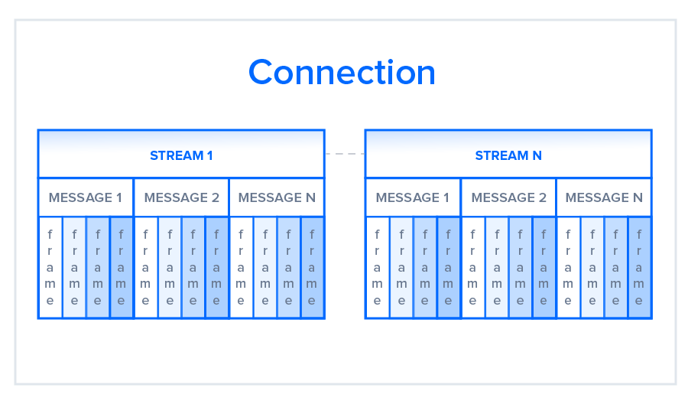

At the most granular level, the communication channel consists of a bunch of binary-encoded frames, each tagged to a particular stream. The identifying tags allow the connection to interleave these frames during transfer and reassemble them at the other end. The interleaved requests and responses can run in parallel without blocking the messages behind them, a process called multiplexing. Multiplexing resolves the head-of-line blocking issue in HTTP/1.1 by ensuring that no message has to wait for another to finish. This also means that servers and clients can send concurrent requests and responses, allowing for greater control and more efficient connection management.

Since multiplexing allows the client to construct multiple streams in parallel, these streams only need to make use of a single TCP connection. Having a single persistent connection per origin improves upon HTTP/1.1 by reducing the memory and processing footprint throughout the network. This results in better network and bandwidth utilization and thus decreases the overall operational cost.

A single TCP connection also improves the performance of the HTTPS protocol, since the client and server can reuse the same secured session for multiple requests/responses. In HTTPS, during the TLS or SSL handshake, both parties agree on the use of a single key throughout the session. If the connection breaks, a new session starts, requiring a newly generated key for further communication. Thus, maintaining a single connection can greatly reduce the resources required for HTTPS performance. Note that, though HTTP/2 specifications do not make it mandatory to use the TLS layer, many major browsers only support HTTP/2 with HTTPS.

Although the multiplexing inherent in the binary framing layer solves certain issues of HTTP/1.1, multiple streams awaiting the same resource can still cause performance issues. The design of HTTP/2 takes this into account, however, by using stream prioritization, a topic we will discuss in the next section.

### **HTTP/2 — Stream Prioritization**

Stream prioritization not only solves the possible issue of requests competing for the same resource, but also allows developers to customize the relative weight of requests to better optimize application performance. In this section, we will break down the process of this prioritization in order to provide better insight into how you can leverage this feature of HTTP/2.

As you know now, the binary framing layer organizes messages into parallel streams of data. When a client sends concurrent requests to a server, it can prioritize the responses it is requesting by assigning a weight between 1 and 256 to each stream. The higher number indicates higher priority. In addition to this, the client also states each stream’s dependency on another stream by specifying the ID of the stream on which it depends. If the parent identifier is omitted, the stream is considered to be dependent on the root stream. This is illustrated in the following figure:

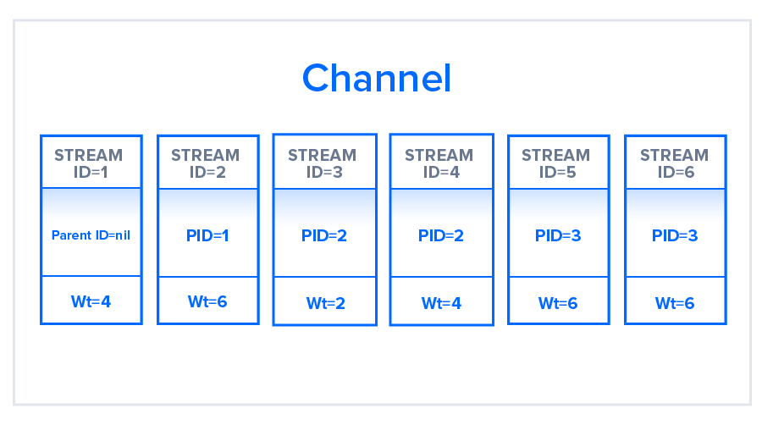

In the illustration, the channel contains six streams, each with a unique ID and associated with a specific weight. Stream 1 does not have a parent ID associated with it and is by default associated with the root node. All other streams have some parent ID marked. The resource allocation for each stream will be based on the weight that they hold and the dependencies they require. Streams 5 and 6 for example, which in the figure have been assigned the same weight and same parent stream, will have the same prioritization for resource allocation.

### **HTTP/1.1**

In HTTP/1.1, flow control relies on the underlying TCP connection. When this connection initiates, both client and server establish their buffer sizes using their system default settings. If the receiver’s buffer is partially filled with data, it will tell the sender its receive window, i.e., the amount of available space that remains in its buffer. This receive window is advertised in a signal known as an ACK packet, which is the data packet that the receiver sends to acknowledge that it received the opening signal. If this advertised receive window size is zero, the sender will send no more data until the client clears its internal buffer and then requests to resume data transmission. It is important to note here that using receive windows based on the underlying TCP connection can only implement flow control on either end of the connection.

Because HTTP/1.1 relies on the transport layer to avoid buffer overflow, each new TCP connection requires a separate flow control mechanism. HTTP/2, however, multiplexes streams within a single TCP connection, and will have to implement flow control in a different manner.

### **HTTP/2**

HTTP/2 multiplexes streams of data within a single TCP connection. As a result, receive windows on the level of the TCP connection are not sufficient to regulate the delivery of individual streams. HTTP/2 solves this problem by allowing the client and server to implement their own flow controls, rather than relying on the transport layer. The application layer communicates the available buffer space, allowing the client and server to set the receive window on the level of the multiplexed streams. This fine-scale flow control can be modified or maintained after the initial connection via a WINDOW_UPDATE frame.

Since this method controls data flow on the level of the application layer, the flow control mechanism does not have to wait for a signal to reach its ultimate destination before adjusting the receive window. Intermediary nodes can use the flow control settings information to determine their own resource allocations and modify accordingly. In this way, each intermediary server can implement its own custom resource strategy, allowing for greater connection efficiency.

This flexibility in flow control can be advantageous when creating appropriate resource strategies. For example, the client may fetch the first scan of an image, display it to the user, and allow the user to preview it while fetching more critical resources. Once the client fetches these critical resources, the browser will resume the retrieval of the remaining part of the image. Deferring the implementation of flow control to the client and server can thus improve the perceived performance of web applications.

In terms of flow control and the stream prioritization mentioned in an earlier section, HTTP/2 provides a more detailed level of control that opens up the possibility of greater optimization. The next section will explain another method unique to the protocol that can enhance a connection in a similar way: predicting resource requests with server push.

## **Predicting Resource Requests**

In a typical web application, the client will send a GET request and receive a page in HTML, usually the index page of the site. While examining the index page contents, the client may discover that it needs to fetch additional resources, such as CSS and JavaScript files, in order to fully render the page. The client determines that it needs these additional resources only after receiving the response from its initial GET request, and thus must make additional requests to fetch these resources and complete putting the page together. These additional requests ultimately increase the connection load time.

There are solutions to this problem, however: since the server knows in advance that the client will require additional files, the server can save the client time by sending these resources to the client before it asks for them. HTTP/1.1 and HTTP/2 have different strategies of accomplishing this, each of which will be described in the next section.

### **HTTP/1.1 — Resource Inlining**

In HTTP/1.1, if the developer knows in advance which additional resources the client machine will need to render the page, they can use a technique called resource inlining to include the required resource directly within the HTML document that the server sends in response to the initial GET request. For example, if a client needs a specific CSS file to render a page, inlining that CSS file will provide the client with the needed resource before it asks for it, reducing the total number of requests that the client must send.

But there are a few problems with resource inlining. Including the resource in the HTML document is a viable solution for smaller, text-based resources, but larger files in non-text formats can greatly increase the size of the HTML document, which can ultimately decrease the connection speed and nullify the original advantage gained from using this technique. Also, since the inlined resources are no longer separate from the HTML document, there is no mechanism for the client to decline resources that it already has, or to place a resource in its cache. If multiple pages require the resource, each new HTML document will have the same resource inlined in its code, leading to larger HTML documents and longer load times than if the resource were simply cached in the beginning.

A major drawback of resource inlining, then, is that the client cannot separate the resource and the document. A finer level of control is needed to optimize the connection, a need that HTTP/2 seeks to meet with server push.

### **HTTP/2 — Server Push**

Since HTTP/2 enables multiple concurrent responses to a client’s initial GET request, a server can send a resource to a client along with the requested HTML page, providing the resource before the client asks for it. This process is called server push. In this way, an HTTP/2 connection can accomplish the same goal of resource inlining while maintaining the separation between the pushed resource and the document. This means that the client can decide to cache or decline the pushed resource separate from the main HTML document, fixing the major drawback of resource inlining.

In HTTP/2, this process begins when the server sends a PUSH_PROMISE frame to inform the client that it is going to push a resource. This frame includes only the header of the message, and allows the client to know ahead of time which resource the server will push. If it already has the resource cached, the client can decline the push by sending a RST_STREAM frame in response. The PUSH_PROMISE frame also saves the client from sending a duplicate request to the server, since it knows which resources the server is going to push.

It is important to note here that the emphasis of server push is client control. If a client needed to adjust the priority of server push, or even disable it, it could at any time send a SETTINGS frame to modify this HTTP/2 feature.

Although this feature has a lot of potential, server push is not always the answer to optimizing your web application. For example, some web browsers cannot always cancel pushed requests, even if the client already has the resource cached. If the client mistakenly allows the server to send a duplicate resource, the server push can use up the connection unnecessarily. In the end, server push should be used at the discretion of the developer. For more on how to strategically use server push and optimize web applications, check out the [PRPL pattern](https://developers.google.com/web/fundamentals/performance/prpl-pattern/) developed by Google. To learn more about the possible issues with server push, see Jake Archibald’s blog post [HTTP/2 push is tougher than I thought](https://jakearchibald.com/2017/h2-push-tougher-than-i-thought/).

*----------------------------------------------------------------end-------------------------------------------------------------------*

**Internal Representation Of Objects In Java Script**

Objects, in JavaScript, is it’s most important data-type and forms the building blocks for modern JavaScript. These objects are quite different from JavaScript’s primitive data-types(Number, String, Boolean, null, undefined and symbol) in the sense that while these primitive data-types all store a single value each (depending on their types).

Objects are more complex and each object may contain any combination of these primitive data-types as well as reference data-types.  
 An object, is a reference data type. Variables that are assigned a reference value are given a reference or a pointer to that value. That reference or pointer points to the location in memory where the object is stored. The variables don’t actually store the value.

Loosely speaking, objects in JavaScript may be defined as an unordered collection of related data, of primitive or reference types, in the form of “key: value” pairs. These keys can be variables or functions and are called properties and methods, respectively, in the context of an object.  
 An object can be created with figure brackets {…} with an optional list of properties. A property is a “key: value” pair, where a key is a string (also called a “property name”), and value can be anything.

To understand this rather abstract definition, let us look at an example of a JavaScript Object :

let school = {  
name : “Vivekananda School”,  
location : “Delhi”,  
established : “1971”  
}  
 In the above example “name”, “location”, “established” are all “keys” and “Vivekananda School”, “Delhi” and 1971 are values of these keys respectively.

Each of these keys is referred to as properties of the object. An object in JavaScript may also have a function as a member, in which case it will be known as a method of that object.

Let us see such an example :  
// javascript code demonstrating a simple object  
let school = {  
name: ‘Vivekananda School’,  
location : ‘Delhi’,  
established : ‘1971’,  
displayInfo : function(){  
console.log(${school.name} was established  
in ${school.established} at ${school.location});  
}  
}  
school.displayInfo();

Output:  
 In the above example, “displayinfo” is a method of the school object that is being used to work with the object’s data, stored in its properties.  
Properties of JavaScript Object  
 The property names can be strings or numbers. In case the property names are numbers, they must be accessed using the “bracket notation” like this :  
let school = {  
name: ‘Vivekananda School’,  
location : ‘Delhi’,  
established : ‘1971’,  
20 : 1000,  
displayInfo : function(){  
console.log(The value of the key 20 is ${school[‘20’]});  
}  
}  
school.displayInfo();

Output:  
 But more on the bracket notation later.  
 Property names can also be strings with more than one space separated words. In which case, these property names must be enclosed in quotes :  
let school = {  
“school name” : “Vivekananda School”,  
}  
Like property names which are numbers, they must also be accessed using the bracket notation.

Like if we want to access the ‘Vivekananda’ from ‘Vivekananda School’ we can do something like this:  
// bracket notation  
let school = {  
name: ‘Vivekananda School’,  
displayInfo : function(){  
console.log(${school.name.split(‘ ‘)[0]});  
}  
}  
school.displayInfo(); // Vivekananda

Output:  
 In the above code, we made use of bracket notation and also split method provided by javascript which you will learn about in strings article.  
Creating Objects  
 There are several ways or syntax’s to create objects. One of which, known as the Object literal syntax, we have already used. Besides the object literal syntax, objects in JavaScript may also be created using the constructors, Object Constructor or the prototype pattern.  
 Using the Object literal syntax : Object literal syntax uses the {…} notation to initialize an object an its methods/properties directly.

Let us look at an example of creating objects using this method :  
var obj = {  
member1 : value1,  
member2 : value2,  
};  
 These members can be anything — strings, numbers, functions, arrays or even other objects. An object like this is referred to as an object literal. This is different from other methods of object creation which involve using constructors and classes or prototypes, which have been discussed below.

Object Constructor : Another way to create objects in JavaScript involves using the “Object” constructor. The Object constructor creates an object wrapper for the given value. This, used in conjunction with the “new” keyword allows us to initialize new objects.  
Example :  
const school = new Object();  
school.name = ‘Vivekanada school’;  
school.location = ‘Delhi’;  
school.established = 1971;

school.displayInfo = function(){  
console.log(${school.name} was established  
in ${school.established} at ${school.location});  
}

school.displayInfo();  
Output:  
 The two methods mentioned above are not well suited to programs that require the creation of multiple objects of the same kind, as it would involve repeatedly writing the above lines of code for each such object. To deal with this problem, we can make use of two other methods of object creation in JavaScript that reduces this burden significantly, as mentioned below:  
 Constructors: Constructors in JavaScript, like in most other OOP languages, provides a template for creation of objects. In other words, it defines a set of properties and methods that would be common to all objects initialized using the constructor.

Let us see an example :  
function Vehicle(name, maker) {  
this.name = name;  
this.maker = maker;  
}

let car1 = new Vehicle(‘Fiesta’, ‘Ford’);  
let car2 = new Vehicle(‘Santa Fe’, ‘Hyundai’)

console.log(car1.name); // Output: Fiesta  
console.log(car2.name); // Output: Santa Fe

Output:  
Notice the usage of the “new” keyword before the function Vehicle. Using the “new” keyword in this manner before any function turns it into a constructor. What the “new Vehicle()” actually does is :  
It creates a new object and sets the constructor property of the object to schools (It is important to note that this property is a special default property that is not enumerable and cannot be changed by setting a “constructor: someFunction” property manually).

Then, it sets up the object to work with the Vehicle function’s prototype object ( Each function in JavaScript gets a prototype object, which is initially just an empty object but can be modified.The object, when instantiated inherits all properties from its constructor’s prototype object).

Then calls Vehicle() in the context of the new object, which means that when the “this” keyword is encountered in the constructor(vehicle()), it refers to the new object that was created in the first step.  
Once this is finished, the newly created object is returned to car1 and car2(in the above example).

Inside classes, there can be special methods named constructor().  
class people {  
constructor()  
{  
this.name = “Adam”;  
}  
}

let person1 = new people();

// Output : Adam  
console.log(person1.name);

Output:  
Having more than one function in a class with the name of constructor() results in an error.  
 Prototypes : Another way to create objects involves using prototypes. Every JavaScript function has a prototype object property by default(it is empty by default). Methods or properties may be attached to this property. A detailed description of prototypes is beyond the scope of this introduction to objects.

However you may familiarize yourself with the basic syntax used as below:  
let obj = Object.create(prototype_object, propertiesObject)  
// the second propertiesObject argument is optional  
An example of making use of the Object.create() method is:  
let footballers = {  
position: “Striker”  
}

let footballer1 = Object.create(footballers);

// Output : Striker  
console.log(footballer1.position);  
Output:  
In the above example footballers served as a prototype for creating the object “footballer1”.

All objects created in this way inherits all properties and methods from its prototype objects. Prototypes can have prototypes and those can have prototypes and so on. This is referred to as prototype chaining in JavaScript. This chain terminates with the Object.prototype which is the default prototype fallback for all objects. Javascript objects, by default, inherit properties and methods from Object.prototype but these may easily be overridden. It is also interesting to note that the default prototype is not always Object.prototype.For example Strings and Arrays have their own default prototypes — String.prototype and Array.prototype respectively.

Accessing Object Members  
Object members(properties or methods) can be accessed using the  
dot notation :  
(objectName.memberName)  
let school = {  
name : “Vivekanada”,  
location : “Delhi”,  
established : 1971,  
20 : 1000,  
displayinfo : function() {  
console.log(${school.name} was established  
in ${school.established} at ${school.location});  
}

}

console.log(school.name);

console.log(school.established);  
Output:

Bracket Notation :  
objectName[“memberName”]  
let school = {  
name : “Vivekanada School”,  
location : “Delhi”,  
established : 1995,  
20 : 1000,  
displayinfo : function() {  
document.write(${school.name} was established  
in ${school.established} at ${school.location});  
}  
}

// Output : Vivekanada School  
console.log(school[‘name’]);

// Output: 1000  
console.log(school[‘20’]);  
Output:  
Unlike the dot notation, the bracket keyword works with any string combination, including, but not limited to multi-word strings.

For example:  
somePerson.first name // invalid  
somePerson[“first name”] // valid  
Unlike the dot notation, the bracket notation can also contain names which are results of any expressions variables whose values are computed at run-time.  
For instance :  
let key = “first name” somePerson[key] = “Name Surname”  
Similar operations are not possible while using the dot notation.

